Benjamin Parsons
x Hannah Payne

Press Release, 23/02/2024

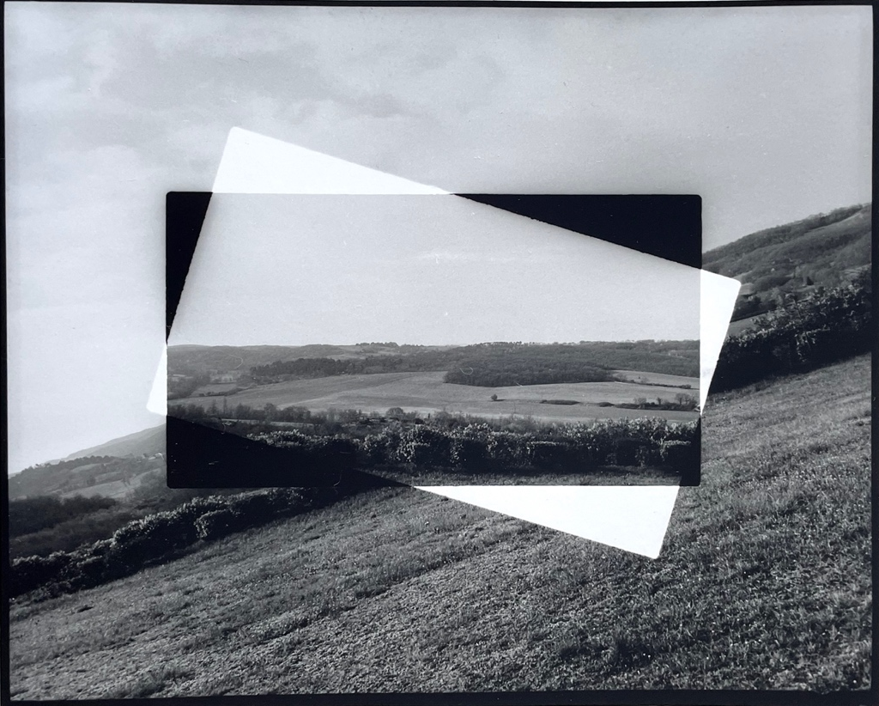

Aliki Braine, Borrowed Landscape, 1, 2023

Benjamin Parsons x Hannah Payne is delighted to announce Aliki Braine | Borrowed Landscapes, at Cromwell Place, London 13 – 17 March 2024 (Private View Tuesday 12 March 6 – 8 pm).

This exhibition, the second solo show with Benjamin Parsons x Hannah Payne gallery, guest curated by Rodrigo Orrantia, focuses on artist and art historian Aliki Braine’s interest in the representation of landscape in western art. Making the most of Cromwell Place’s proximity to the V&A, Braine draws inspiration from a selection of works in the collection, as well as working directly with found facsimile prints of celebrated landscape artists such as Corot, Constable and Jacob van Ruisdael.

Through rigorous experimentation with photography and its essential quality as a medium which can ‘borrow’ and reproduce images, the different series which are included in this exhibition examine and subvert the traditional representation of landscape. Using artistic devices that have become synonymous with her work - cutting, punching out, folding and layering - Braine reconfigures her own and appropriated images to create these ‘borrowed landscapes’, inviting us to look at art, but also the world around us in a different way.

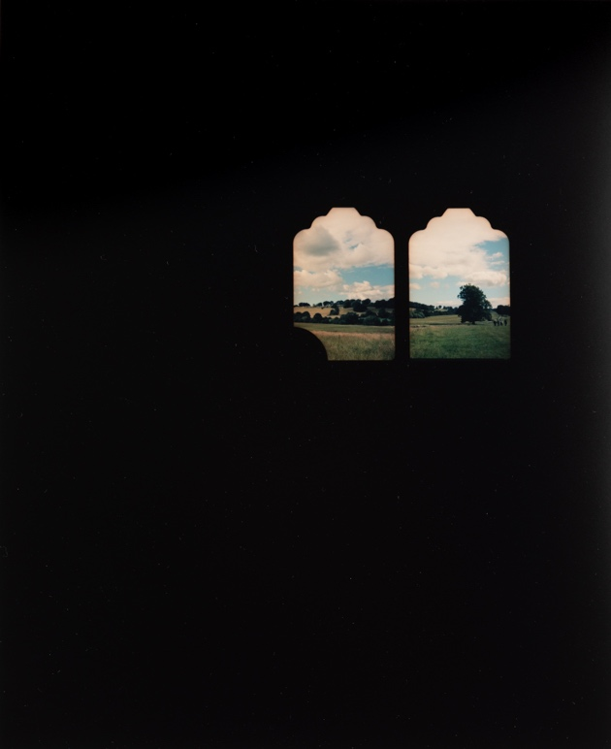

Exhibition Talks and Events:

Private View Tuesday 12 March 6 – 8 pm. As part of Cromwell Place Tuesday LATES:
6.30 pm Introduction to ‘Borrowed Landscapes’ with Aliki Braine. Aliki will provide an introduction to the exhibition with curator, Rodrigo Orrantia.

Thursday 14 March, 2 pm
Walking Tour of Borrowed Landscapes with artist and art historian Aliki Braine including a walk across to the V&A to visit historical landscape paintings from the collection that have inspired Aliki’s practice.

Saturday 16 March, 11 am
Aliki Braine In Conversation with Dr Caroline Molloy, Programme Director Fine Art and Photography – Farnham. Talk is followed by a walk to the V&A museum to visit historical landscape paintings from the collection that have inspired Aliki’s practice.

Notes to Editors

Image credits:
Top: ALIKI BRAINE, Horizontal Shift (Landscape 1), 2023, Black and white photograph from hole-punched and rearranged negative, 86 x 100 cm, Edition 1/3

ALIKI BRAINE, Borrowed Landscape I, 2023, Colour photograph from cut and repositioned negative. Unique Print
21 x 25 cm, Unique Prints (+1A/P)

Aliki Braine | Borrowed Landscapes
Curated by Rodrigo Orrantia, hosted by Benjamin Parsons x Hannah Payne gallery, at Cromwell Place.
13 – 17 March 2024. Private View: Tuesday 12 March 6 – 8 pm.
Exhibtion Talks and Tours: Thursday 14 March, 2 pm
Walking Tour of Borrowed Landscapes with artist and art historian Aliki Braine.
Saturday 16 March, 11 am
Aliki Braine In Conversation with Dr Caroline Molloy, followed by a walk to the V&A museum

Location: Gallery 5, Cromwell Place, London, SW7.
• Tuesday: by appointment only
• Wednesday to Saturday: 11am to 7pm
• Sunday: 11am to 4pm

Contacts:
Hannah Payne - hannah@theartfive.com / 07867871823
Ben Parsons - ben@benjaminparsons.art / 07432 801 256

About Aliki Braine
Aliki Braine was born in Paris in 1976. She has an MFA from The Ruskin School of Fine Art, Oxford University, an MA from The Slade School of Fine Art, London and an MA from The Courtauld Institute of Art where she was awarded a distinction for her masters in 17th century painting. Recent exhibitions include solo shows in London, Birmingham, Vienna,Madrid and Paris. Her work is featured in a number of recent publications including British Art and the Environment, Charlotte Gould and Sophie Mesplède (Routledge, 2022), Pauline Martin,L’Évidence, le vide, la vie; La photographie face à ses lacunes (Ithaque Editions, 2017) and Robert Shore,Post-Photography: The Artist with a Camera (Laurence King Pub, 2014.) Aliki is an associate lecturer for Camberwell College of Art, University of the Arts London and a regular lecturer for Christie’s Education, the Wallace Collection and the National Gallery. She lives and works in London.
alikibraine.com

About Rodrigo Orrantia
Rodrigo Orrantia is an art historian and curator, specialising in photography. Since graduating with an MA in Contemporary and Historical Photography from Sotheby's Institute of Art, he has worked on projects for major museums in the UK, along with art fairs and festivals in UK, Europe and Latin America.
rodrigoorrantia.com

About Benjamin Parsons x Hannah Payne
Presenting a programme of exhibitions including exceptional emerging contemporary, mid-career and established artists, alongside Modern British art, the gallery Oxford is located in picturesque North Parade Avenue in close proximity to Oxford’s leading institutions Ashmolean Museum, and Modern Art Oxford. The gallery’s focus is on the modern and contemporary programme alongside the gallery’s strong secondary market activity. In addition, the gallery offers an advisory service, helping private clients with building and managing their collections.
Benjaminparsons.art

